User Manual

Normal User

Registered users can login

New users can sign up

Search items

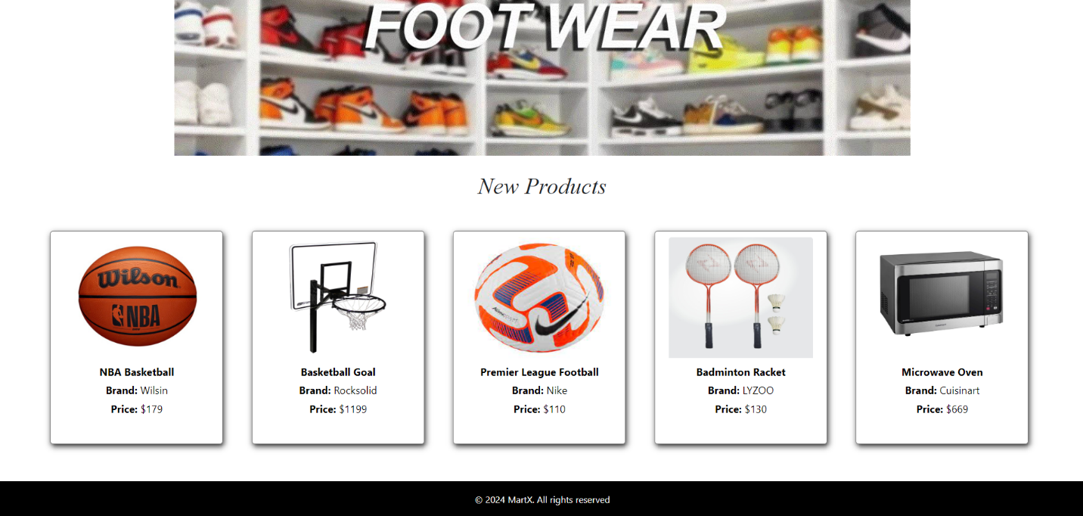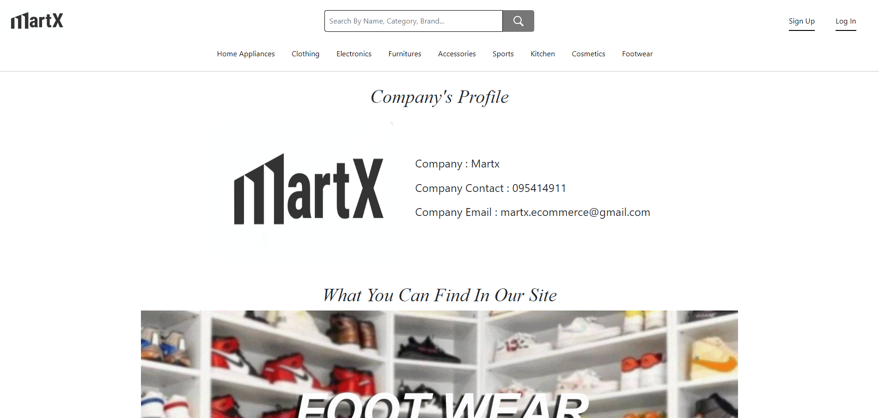

Click the item to view item detail

Click the picture to get into footwear items tab

Click the category to see its items only

Fig (1)

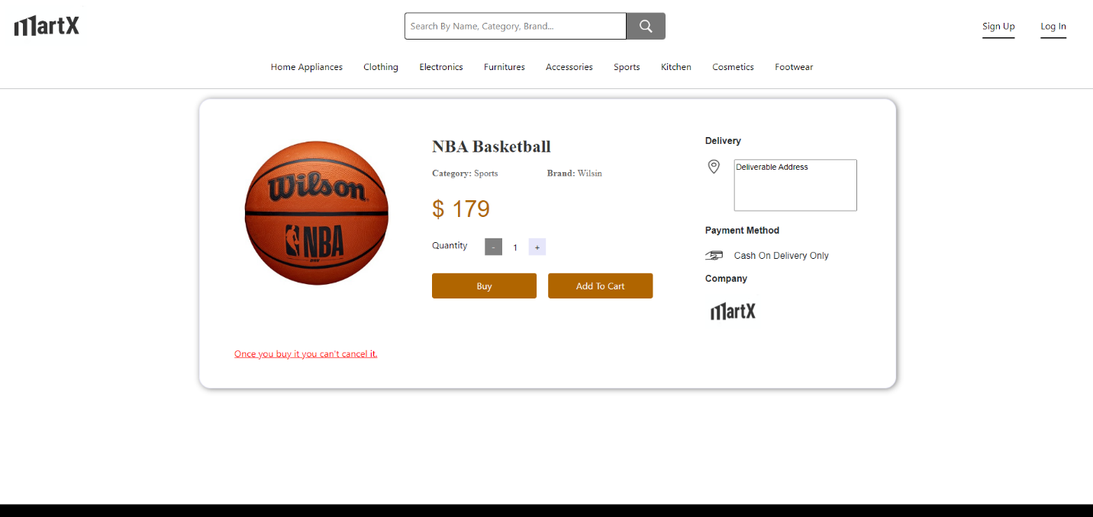

Provide the deliverable address

Can adjust the quantity

Click Buy to appear toast message (before logged-in)

Click Add to Cart to appear toast message (before logged-in)

Click the logo to get into home page

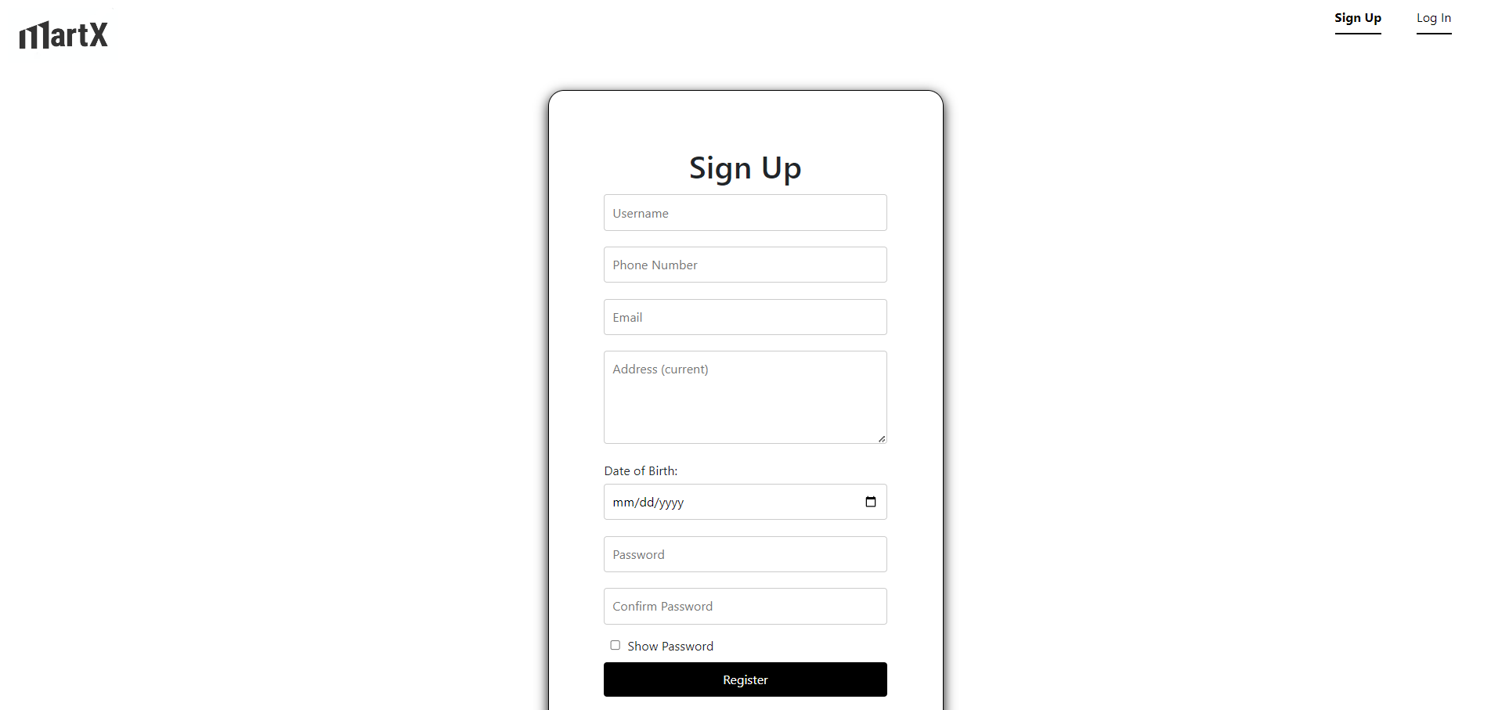

Fill all the inputs and press Register to confirm registration

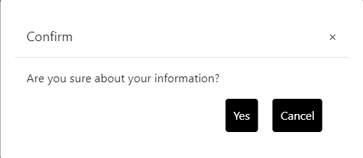

Click Cancel to cancel registration

After pressing yes, registration completes

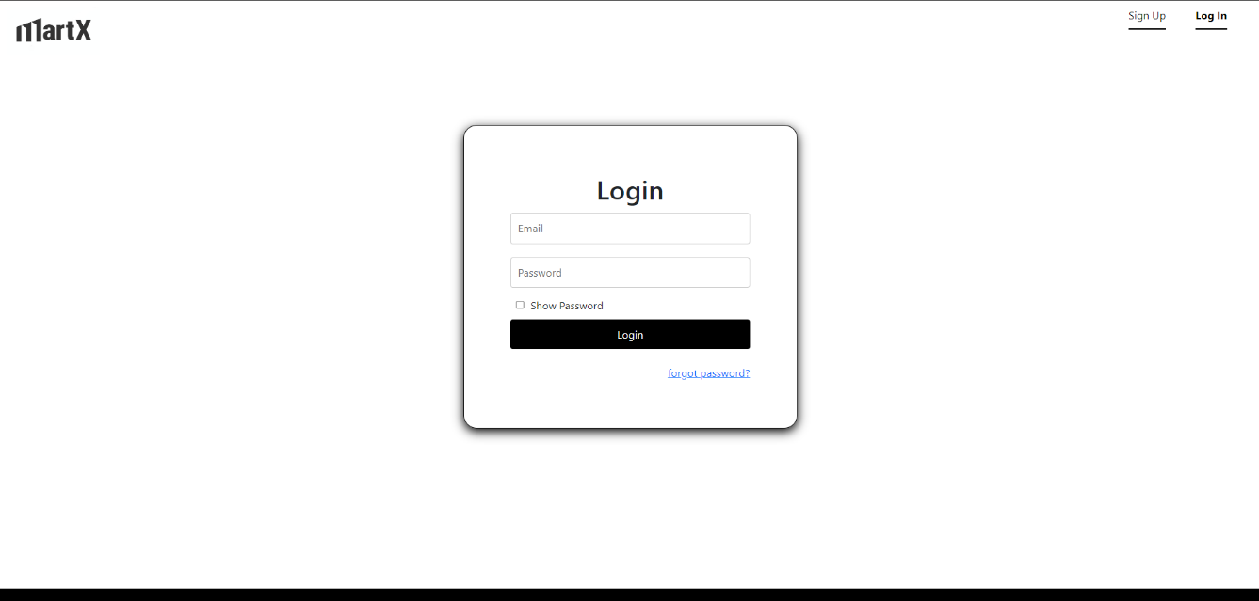

To show password

Can change the password if users forgot

Login using registered email and password

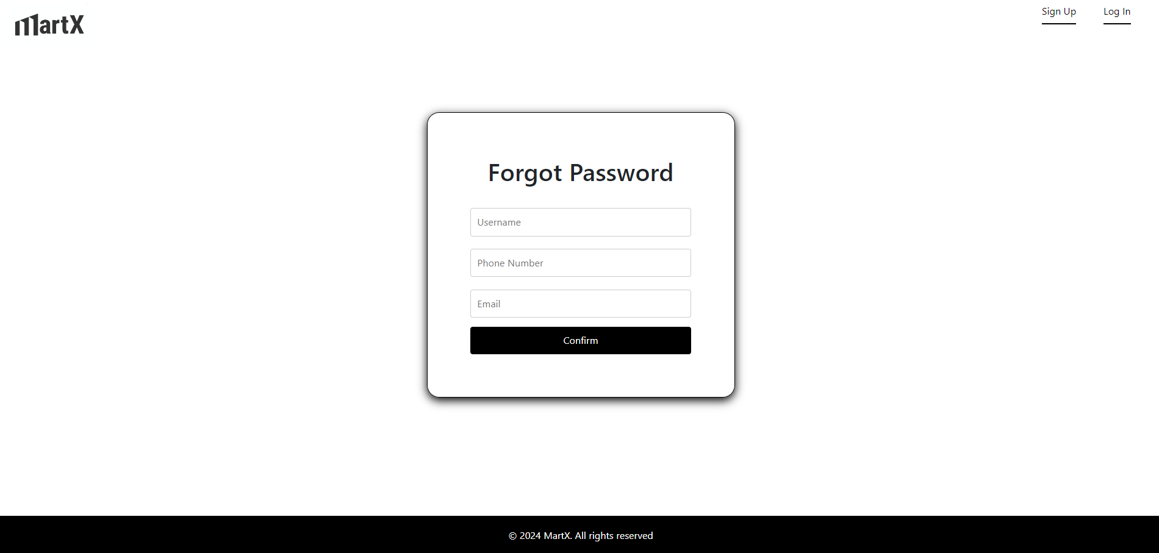

Fill correct information of your registration and press confirm to change new password

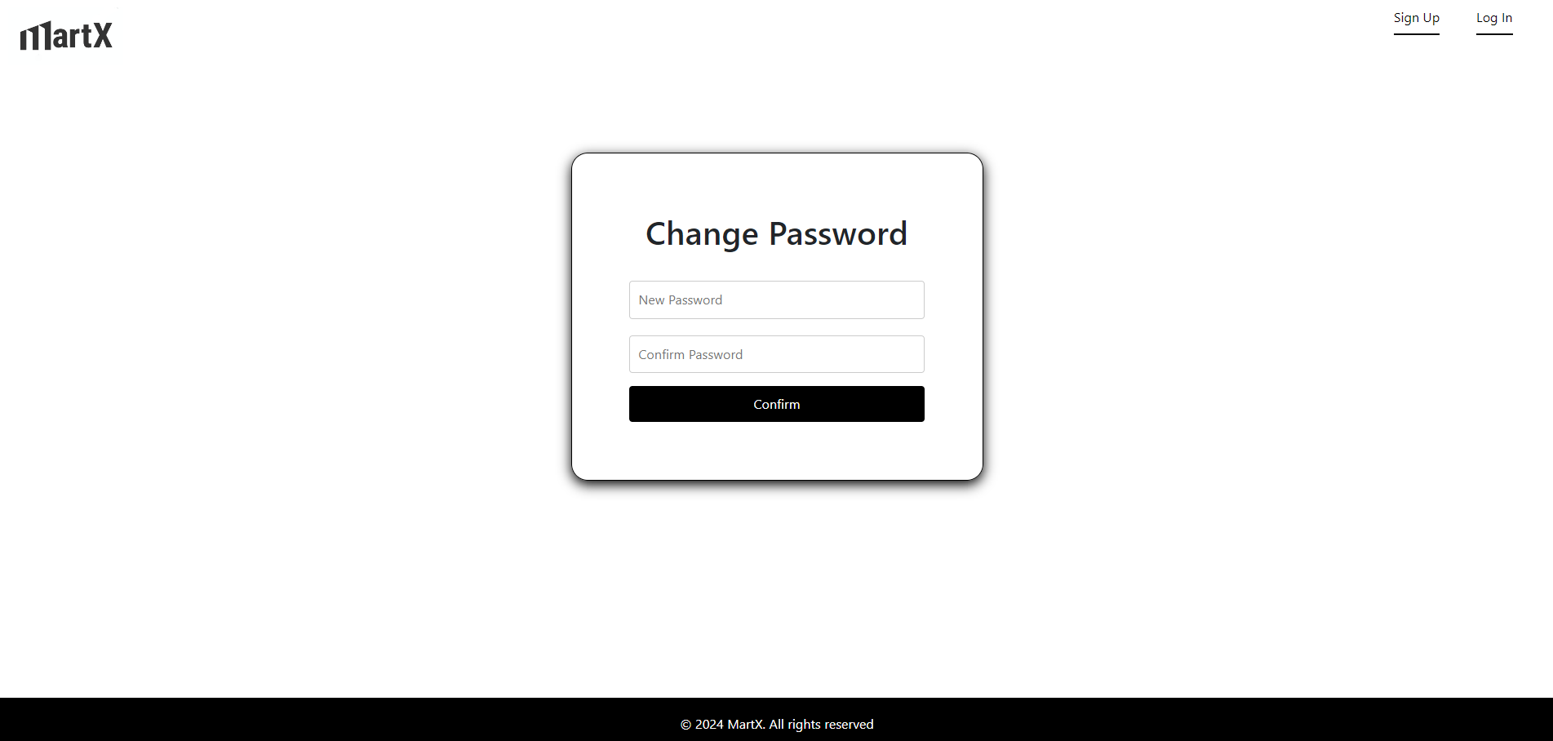

Make new password and press confirm to change password

Click to get into cart

Click the name to view user’s profile

After Loggin-In

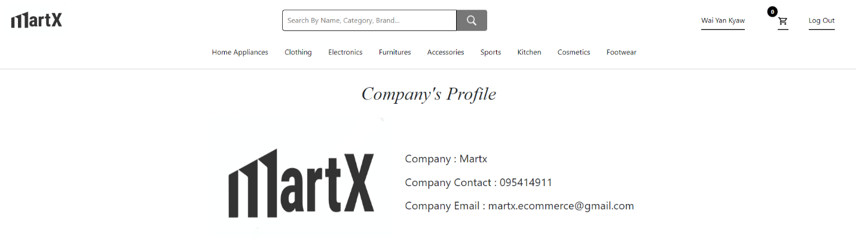

Click to log out

Fig (5)

As shown in Fig (5), user’s name, cart, Log Out appear instead of Sign Up and Log In in Home Page.

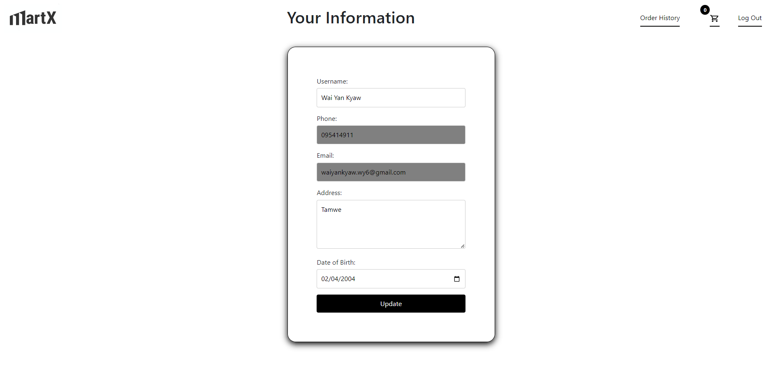

Press this to see order history

After changing information, click update to make confirm box appear.

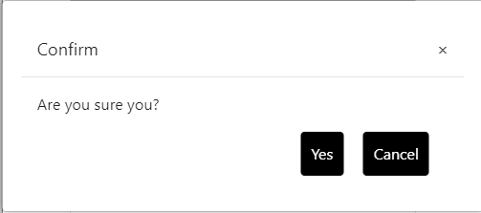

Click Cancel to cancel update.

Click yes to confirm update.

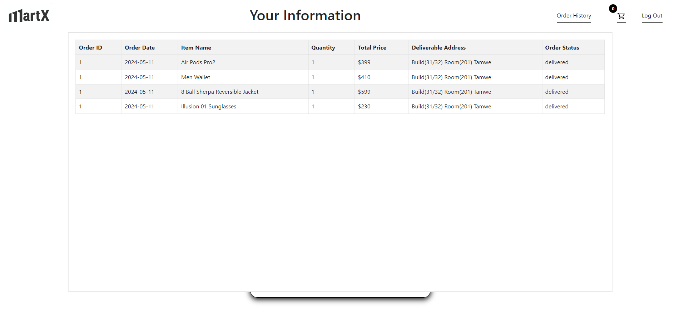

Click on any place to hide the order history

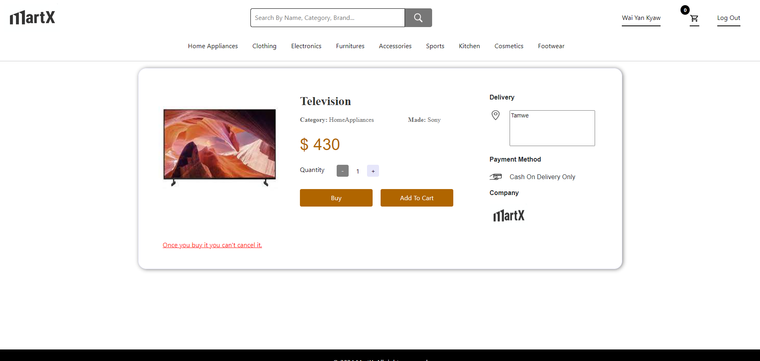

Provide the deliverable address

Choose how much quantity to buy or add to cart

Click Add to Cart to add the item to cart

Click Buy to appear buy confirmation box

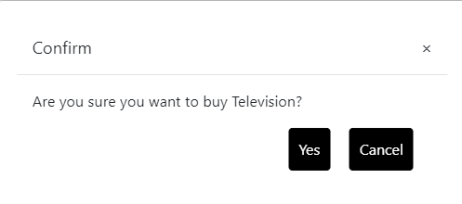

Press Cancel to cancel buying process

Click Yes to buy the item

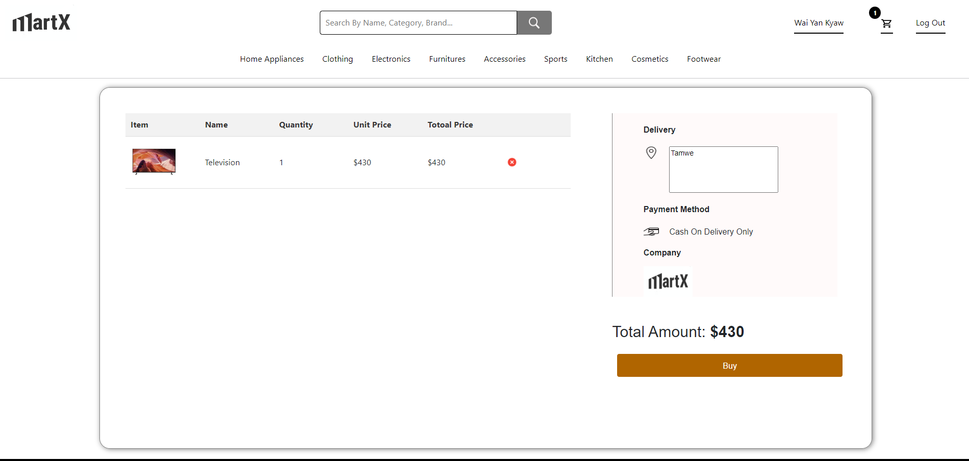

Click Buy to make confirm box appear

Provide the deliverable address

Press this button to remove the item from the cart

This number indicates the total item in the cart

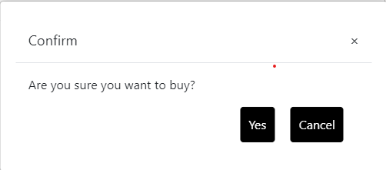

Click Yes to buy items

Press Cancel to cancel buying process

After Admin Log In

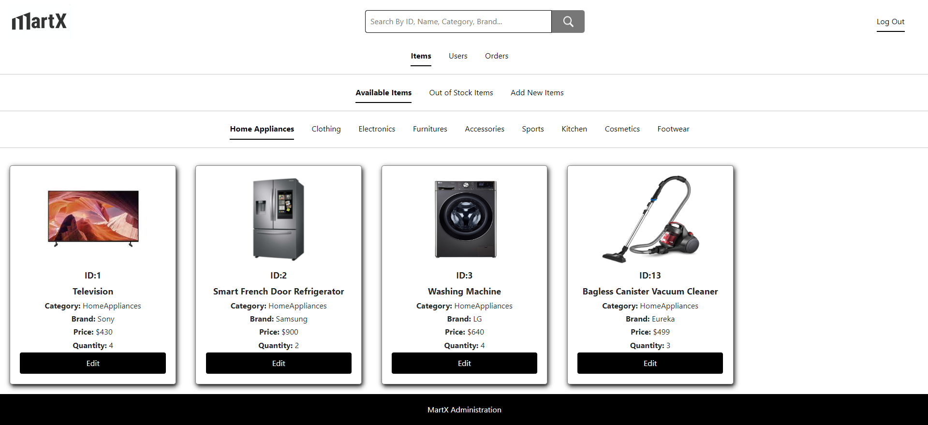

Out of Stock items will be shown here

Available items will be shown here

Press this to log out

Search Items

To edit item, press edit

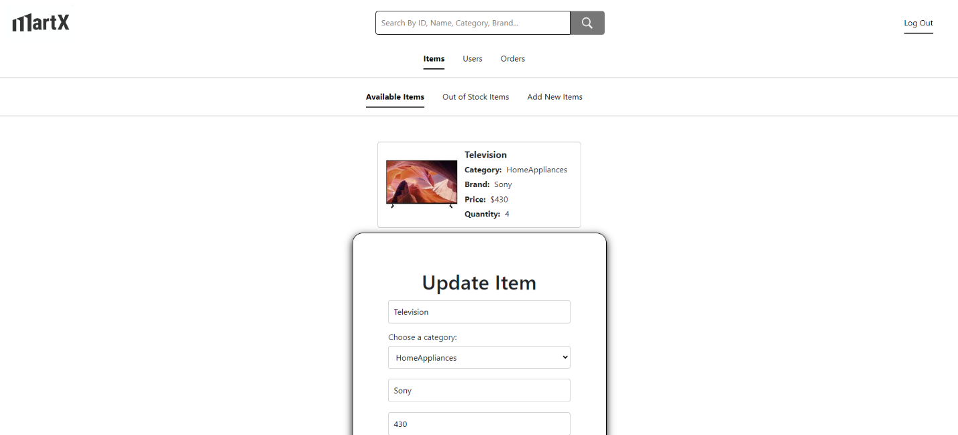



After update data press Update to confirm

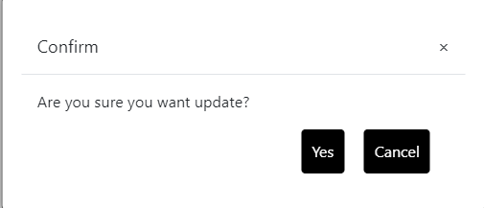

Press Cancel to cancel the update

Press Yes to confirm the update

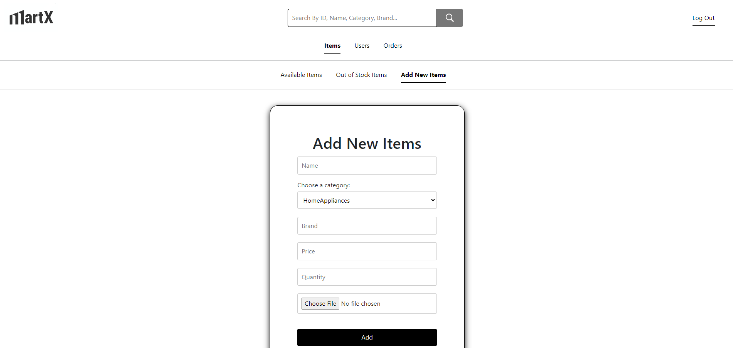

Click Add after entering all required data and confirm box will appear

Get to Add New Items page to add new items

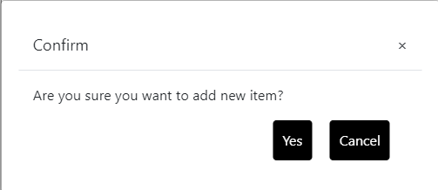

Press Cancel to cancel addition of new data

Press Yes to confirm addition of new data

Clicking this will show all registered users

Search Users

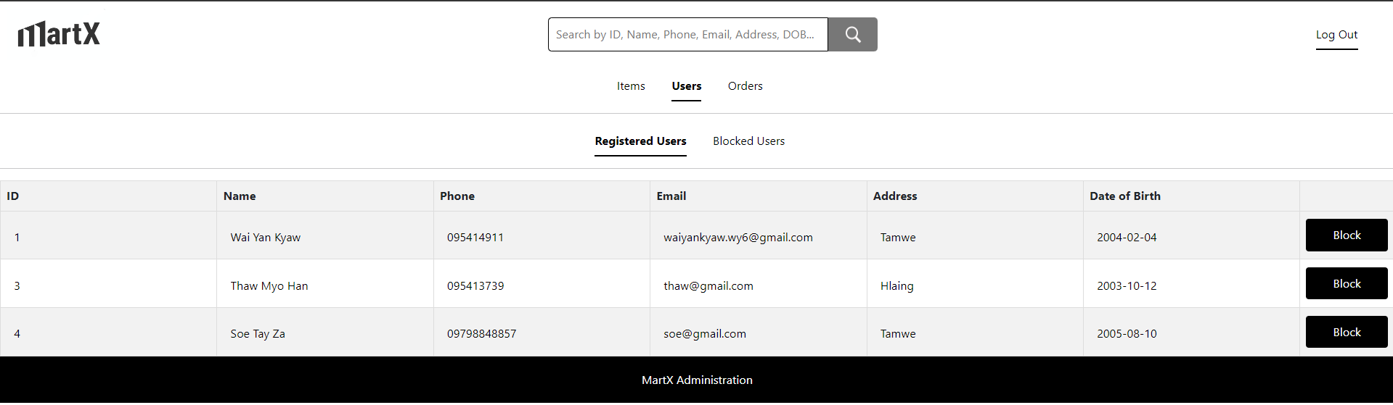

Click to block users

Click Users to get into user page

Clicking this will show all blocked users

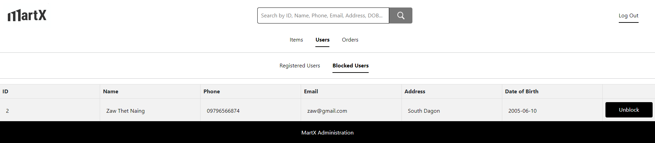

Click to unblock users

Click Orders to get into order page

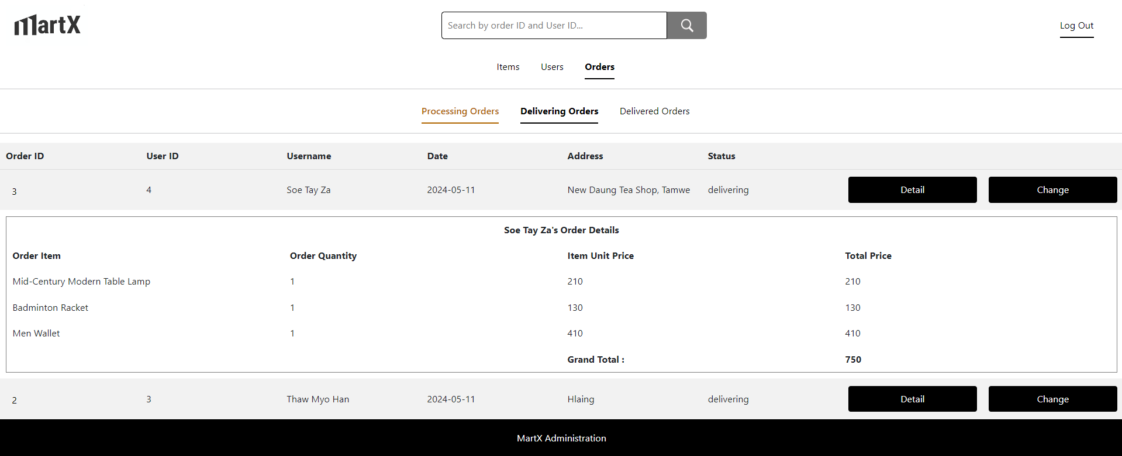

Click this to change order status

Click this to see or to hide order details

Clicking this will show all delivering orders

Clicking this will show all processing orders

Search Orders

Clicking this will show all delivered orders

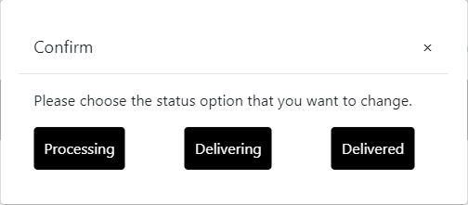

Click this to change the order status to delivering

Click this to change the order status to processing

Click this to change the order status to delivered

*End of User Manual*